Required practical activity: Hydrated Salts
Required Practical Guide – Hydrated Salts

Aim: To use heating to find the percentage water in a hydrated salt
Notes and guidance
You may wish to have students collect the equipment for this themselves from communal trays at the front of the lab. This will help them to develop their skills of equipment recognition and organisation.

If your class do not have a great deal of time to carry out this practical, you may wish to assign a different salt to each group and then compare results after the lesson.

If steel crucibles are not available, steel bottle tops or test tubes can be used. See the alternative methods section below for more information.

Discuss this practical with your technician colleagues in advance. It may be that some hydrated salts are not available and others must be substituted.

Risk Assessment Notes
A risk assessment must be completed for this practical. The risk assessment should be specific to the class involved and written only by the teaching member of staff. For more guidance refer to CLEAPSS. It is good practice for students to wear safety spectacles during all class practicals and demos.

Equipment may be hot after heating. You may wish to use a small section of heatproof mat when weighing to ensure balances are not damaged. If equipment is too hot to clear away at the end of the lesson, alert your technician colleague to this so they do not injure themselves.

Equipment Per Group | 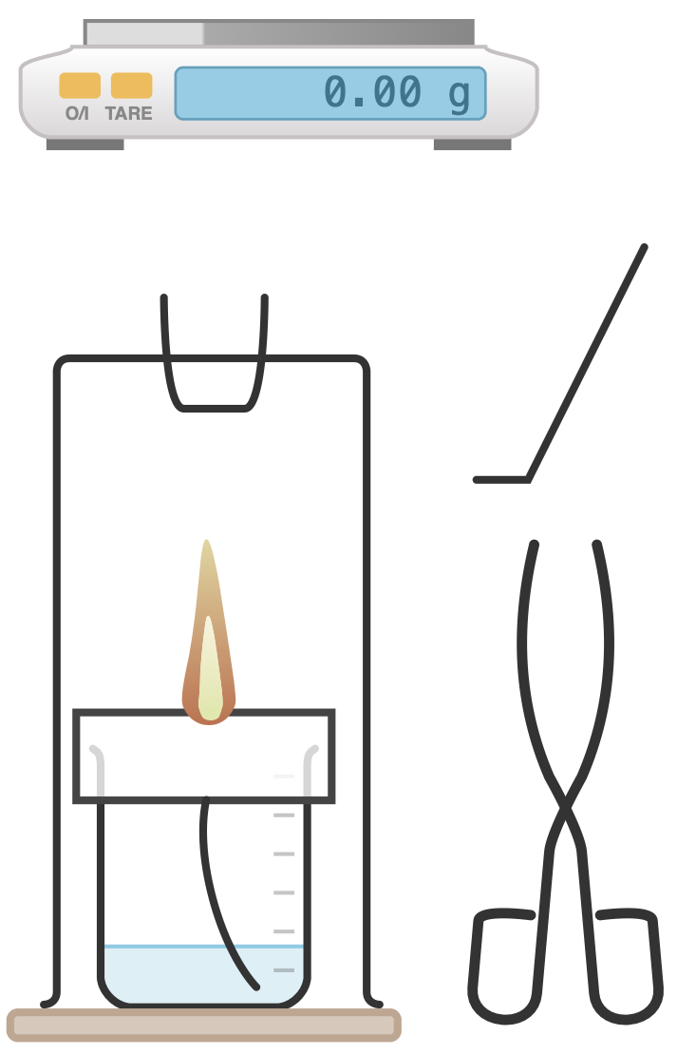
Apparatus:
- Spirit burner (IDA)
- Heat proof mat
- Tripod
- Clay pipe triangle
- Steel crucible
- Spatula
- Tongs
- Balance (2 D.P.)

Chemicals:
- Hydrated salts: CuCl₂.2H₂O, FeSO₄.7H₂O, MgSO₄.7H₂O, MnSO₄.4H₂O

Method |  | Questions To Ask Students During The Practical
- Weigh the empty crucible and record the result as M1.  - Add a small spatula’s worth of hydrated copper sulfate salt to the crucible and find the mass of the crucible plus the salt. Record this as M2.  - Place the crucible containing the hydrated salt in a pipe clay triangle on a tripod above the Bunsen burner and heat proof mat.  - Use the spirit burner to heat the crucible until the blue colour of the hydrated copper sulfate salt is lost and a white-ish powder remains.  - Extinguish the spirit burner and allow the crucible to cool.  - Use tongs to remove the crucible from above the spirit burner and place it on the balance. Weigh the crucible and salt one more time and record the mass of the crucible + anhydrous salt as M3.  - When the crucible is cool, repeat the above steps for other hydrated salts. |  | - Why is it important to tie back long hair and tuck in ties when using spirit burners? (To ensure hair and ties are not accidentally set on fire.)  - Why is it important to stand at our workstations when conducting this experiment? (Sitting does not allow us to quickly move out of the way if something spills or fire spreads on the work surface.)  - Why do allow the crucible to cool before weighing it after heating? (So as to not damage the balance.)  - Why do we use tongs to handle the crucible? (To ensure we do not burn ourselves if the crucible is still hot.)
Calculations |  | Questions To Ask Students During The Calculations
Original mass of hydrated salt = M2 – M1  Mass of water lost from salt = M2 – M3  % water in hydrated salt = [(M2 – M3) x 100] / (M2 – M1) |  | - Why do we give answers only to three significant figures? (This is the fidelity of the measurements we took.)  - What is the percentage water in the hydrated salt you analysed? (This will depend on the hydrated salt analysed. See below.)
Notes on the Hydrated Salts
CuCl₂.2H₂O:
- Theoretical water of crystallisation: 21.1 % by mass
- Loses water 70-200 °C (blue-green → yellow-brown)
- Anhydrous salt decomposes at 993 °C (→ chlorine gas)

FeSO₄.7H₂O:
- Theoretical water of crystallisation: 45.4 % by mass
- Loses water 60-300 °C (green → white)
- Anhydrous salt decomposes at 400 °C

MgSO₄.7H₂O:
- Theoretical water of crystallisation: 51.1 % by mass
- Hydrated solid ‘liquefies’ at ~150 °C (heat slowly during this phase to avoid spitting)
- Anhydrous salt decomposes at 1124 °C

MnSO₄.4H₂O:
- Theoretical water of crystallisation: 32.3 % by mass
- Loss of water begins below 50 °C. Monohydrate loses water ~450 °C (pink → colourless)
- Anhydrous salt decomposes at 850 °C

Alternative Methods/Computer Simulations |  | Clearing up
There are many online videos of this experiment being conducted. However, wherever possible students should experience this practical in person.  If your class do not have a great deal of time to carry out this practical, you may wish to assign a different salt to each group and then compare results after the lesson.  If steel crucibles are not available, steel bottle tops or test tubes can be used. If using steel bottle tops, ensure your technician colleague burns out any plastic before the experiment. Test tubes are not ideal for this experiment as evaporating water can condense at the colder top glass of the tube and then fall back into the salt.  Ceramic crucibles can be expensive and weaken on repeated heating. Therefore steel crucibles are recommended. |  | It is important that equipment is returned to the prep room in good order. If safe to do so, rinse used equipment and put it in the used equipment tray. If the trays arrived on a trolley, students must return all trays and equipment to that trolley. Anything dirty needs to be placed into a separate container for washing up. Never put dirty equipment back into a tray with clean equipment.  Consult CLEAPSS Hazcards for the salts you are using for up-to-date disposal instructions. Never flush down a drain chemicals that are meant to be disposed of in other ways.  Equipment may be hot after heating. If equipment is too hot to clear away at the end of the lesson, alert your technician colleague to this so they do not injure themselves.
Technician Notes
Ensure the chemicals you provide are free from contamination and the equipment is as clean as possible.

Discuss this practical with the class teacher ahead of time. Ensure they have considered the risks of this practical and are confident with the techniques used. If necessary, provide them with the CLEAPSS hazcards (identified in the risk section section above) so they are comfortable with the chemicals to be used and how to use and dispose of them safely.

Bunsen burner flames are of a sufficiently high temperature to cause decomposition of the anhydrous salts, which can release toxic and corrosive gases. As such, IDA spirit burners should be used. Home-made spirit burners can be constructed from common materials – see CLEAPSS GL157 for instructions on how to do this.

